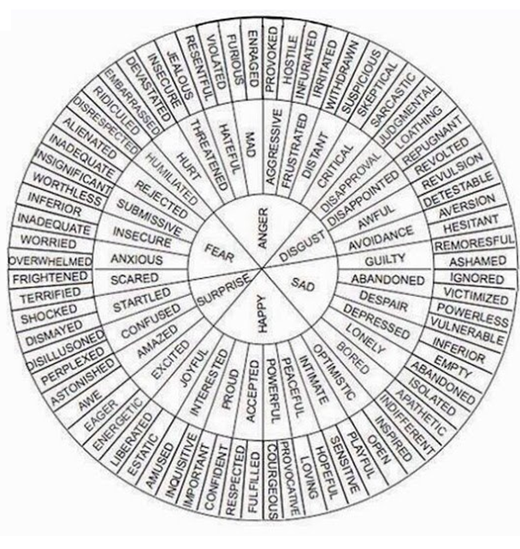
Start in the inner circle where you can find 6 basic emotional states:
happy / sad / disgust / anger / fear / surprise

The middle circle shows you different types of happiness, sadness, disgust, anger, fear and surprise, ranging from not so strong emotions such as bored to much stronger emotions such as despair.

The outer circle provides you with two synonyms (words with a similar but not exactly the same meaning) for the emotional states in the middle circle.

How are you feeling today? I’m feeling happy.
What kind of happy? I’m feeling positive.
Why are you feeling positive? I’m feeling positive because the sun is shining

Every morning, Sam is so enthusiastic to begin his day that he jumps out of bed and begins to sing.
His mother became worried when she didn't hear from him for two days.
David is quite shy so he doesn't like talking to people he doesn't know.
Even though I am accustomed to traveling for business, I still get homesick if I am away from my home for more than a week.
Katie feels threatened every time her boyfriend talks to another girl. She thinks that every girl wants to steal him.
In the U.S., Thanksgiving is a holiday in which people give thanks for the blessings they have. Before the Thanksgiving meal, family members will say what they are thankful for.
I am absolutely furious!! I cannot believe that my dog chewed my favorite shoes. Now they're ruined!
Cats are so curious that they often get into trouble. Once, my cat fell into the bath tub because she wanted to know what was inside!
After his grandmother passed away, Ken was so grief-stricken he couldn't get out of bed.
When Emily has a lot of work to do and feels stressed, she becomes very tense and cannot relax.
Our friend Lily makes us feel left out when she has a party but doesn't invite us.
Even in hard times when I don't have a lot of money, I stay hopeful and believe that next month will be better.
As a teenager, Alexandra liked to be rebellious. She used to sneak out of the house after her parents fell asleep to go to parties.
When I see that puzzled look on your face, I know that you didn't understand my question.
Mr. and Mrs. Porter are very cautious about answering their door. If they are not expecting a visitor, they won't open the door.
Wow! I'm really impressed that Ashley can speak 7 languages, whereas I only speak one!
Ugh! I don't have anything to do. I'm so bored!!
It's difficult to not become discouraged while looking for a job, especially when you hand out your resume to employers and no one calls you.
After Kylie had her heart broken by her ex-boyfriend, she felt so down and blue. I tried to cheer her up, but she just wants to be sad for a while.

affection – чувство близости
amity – мирные отношения
attachment – преданность
attraction – привлекательность
awe – трепет
care – забота
confidence – уверенность
consolation – утешение
despair – отчаяние
disappointment – разочарование
disgust – омерзение
embarrassment – смущение
enjoyment – наслаждение
enmity – вражда
grief – скорбь
honesty – честность
hostility – враждебность
humiliation – унижение
indifference – безразличие
joy – радость
lie – ложь
love – любовь
regret – сожаление
remorse – раскаяние
satisfaction – удовлетворение
sincerity – искренность
sympathy – сочувствие
annoyance – раздражение
antipathy – антипатия
anxiety – беспокойство
desire – страсть
dislike – неприязнь
frustration – расстройство
pleasure – удовольствие
irritation – недовольство
shame – стыд
sorrow – печаль
sadness – грусть
merriment – веселье
anger – злость
confusion – смятение
disgrace – позор
disillusionment – разочарование
horror – ужас

