Americans Grade Math as the Most Valuable School Subject

Math is the clear winner when Americans are asked to say which school subject has been most valuable to them in their lives, followed by language arts (English, literature, or reading) - and science.
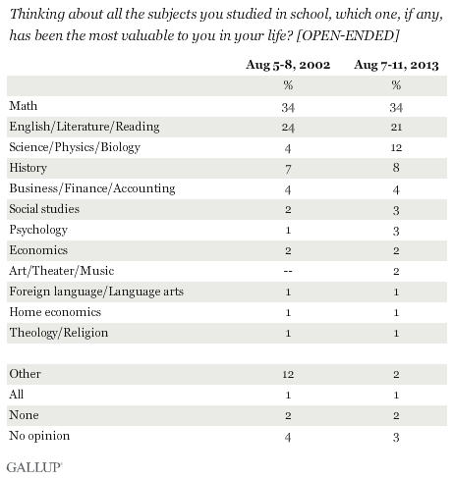
Proponents of focusing on the "three R's" in school - reading, writing, and arithmetic - would be happy to know that U.S. adults report math and English are the school subjects that have been most valuable in their lives. While there is public support for teaching students’ skills such as critical thinking and communication in addition to core subject material, the poll results show the importance of teaching math and English in schools.
Those who want to see an increased emphasis on STEM (science, technology, engineering, and math) training for today's students will also be encouraged to find out that math and science are two of the top three subjects Americans mention.

Americans Say U.S. Schools Should Teach "Soft" Skills
Most Americans believe that today's schools should teach "soft skills". More than three in four adults "strongly agree" that schools should teach critical thinking and communication to children. And 64% of respondents strongly agree that goal setting should be taught, while 61% strongly agree schools should know how to motivate students.
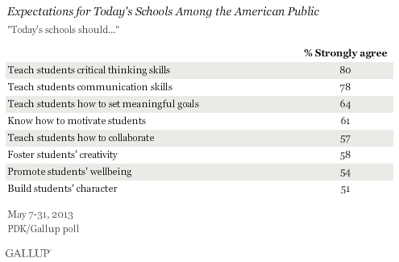
Parents do not see school promoting their child's well-being, relationships with family and friends. When it comes to financial well-being, fewer parents agree that their child's school is involved in teaching their child how to manage finances more effectively.
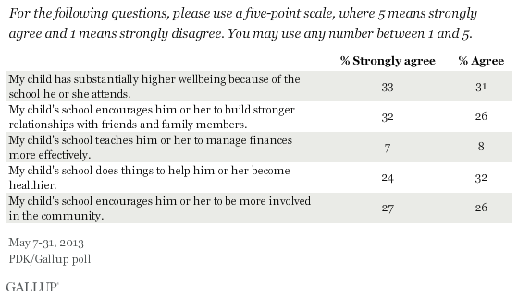
While students’ success may depend on core subjects such as math and reading, it also depends on soft skills. Critical thinking, creativity, communication and other, as well as student physical and social well-being, are also necessary for future success. Students need to be better equipped to analyze information, communicate effectively, and to collaborate with diverse people in a global work environment to solve complex problems.
Task 1. Translate into Russian:
- School should be involved in teaching a child how to manage finances more effectively.
- More than three in four adults "strongly agree" that schools should teach goal setting, critical thinking and communication to children.
- U.S. adults report math and English are the school subjects that have been most valuable in their lives.
- While students’ success may depend on core subjects such as math and reading, it also depends on soft skills.
- Students need to be better equipped to analyze information, communicate effectively, and to collaborate with diverse people in a global work environment to solve complex problems.
Task 2. Translate into English:
- благополучие
- быть лучше оснащенным
- глобальная рабочая среда
- повышенная значимость
- постановка целей
- продвигать
- результаты опроса
- сотрудничать с разными людьми
- сторонник
- управлять финансами более эффективно
- ценный

Task 3. Give the definitions: soft skills, three “R's"

