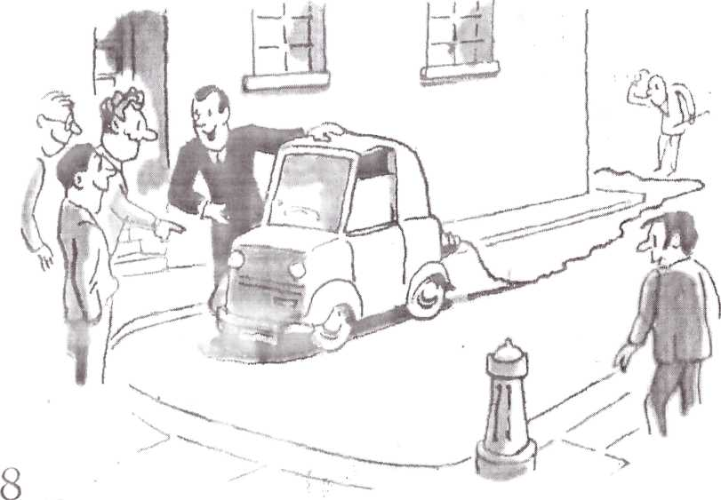

A men was trying to build an electric motor-car. He worked in an office in the town during most of the week, but on Saturdays and Sundays he stayed at home in the country and worked on his electric car. Every Monday he told his friends at the office about his work on the car, but his news about it was never very good. Then at last one Monday morning he came to the office and said to his friends, 'I have done it! I have driven from my home to here by electricity!¹
His friends were all very glad. How much did it cost to get here by electricity?” they asked.
“Three hundred and two pounds,” he answered. “Two pounds for the electricity, and three hundred pounds for the electric wires' from my house to the car.”

ANSWER THE QUESTIONS IN WRITING
- What was the man in this story?
- What was his news about the car like ?
- What happened at last one Monday morning?
- How did his friends feel?
- What did they say?
- What did the man answer?
- Was trying to do?
- What did he do most of the week?
- What did he do on Saturdays?
- What did he do every Monday ?

