Reading Comprehension Task

Read the passages and arrange the benefits in a special order according to their importance for language learning and teaching

Top 6 benefits of using technology in the classroom
It is important to acknowledge that students are already interested and engaged in using technology, this creates many amazing opportunities for schools and teachers to benefit from integrating some forms of technology in the classroom and to make teaching and learning more effective. Here are some of the main benefits of using technology in the classroom.

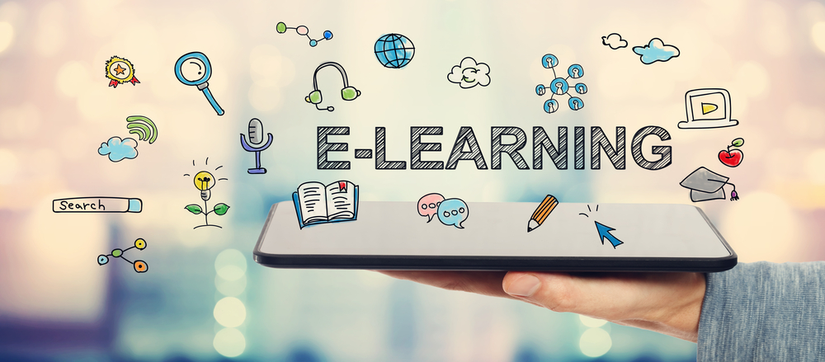.

1.Improves engagement
When technology is integrated into lessons, students are expected to be more interested in the subjects they are studying. Technology provides different opportunities to make learning more fun and enjoyable in terms of teaching same things in new ways. For instance, delivering teaching through gamification, taking students on virtual field trips and using other online learning resources. What is more, technology can encourage a more active participation in the learning process which can be hard to achieve through a traditional lecture environment.
2. Improves knowledge retention
Students who are engaged and interested in things they are studying, are expected to have a better knowledge retention. As mentioned before, technology can help to encourage active participation in the classroom which also is a very important factor for increased knowledge retention. Different forms of technology can be used to experiment with and decide what works best for students in terms of retaining their knowledge.
3.Encourages individual learning
No one learns in the same way because of different learning styles and different abilities. Technology provides great opportunities for making learning more effective for everyone with different needs. For example, students can learn at their own speed, review difficult concepts or skip ahead if they need to. What is more, technology can provide more opportunities for struggling or disabled students. Access to the Internet gives students access to a broad range of resources to conduct research in different ways, which in turn can increase the engagement.
4. Encourages collaboration
Students can practice collaboration skills by getting involved in different online activities. For instance, working on different projects by collaborating with others on forums or by sharing documents on their virtual learning environments. Technology can encourage collaboration with students in the same classroom, same school and even with other classrooms around the world.
5. Students can learn useful life skills through technology
By using technology in the classroom, both teachers and students can develop skills essential for the 21st century. Students can gain the skills they will need to be successful in the future. Modern learning is about collaborating with others, solving complex problems, critical thinking, developing different forms of communication and leadership skills, and improving motivation and productivity. What is more, technology can help develop many practical skills, including creating presentations, learning to differentiate reliable from unreliable sources on the Internet, maintaining proper online etiquette, and writing emails. These are very important skills that can be developed in the classroom.
6. Benefits for teachers
With countless online resources, technology can help improve teaching. Teachers can use different apps or trusted online resources to enhance the traditional ways of teaching and to keep students more engaged. Virtual lesson plans, grading software and online assessments can help teachers save a lot time. This valuable time can be used for working with students who are struggling. What is more, having virtual learning environments in schools enhances collaboration and knowledge sharing between teachers.

