C. Second Conditional (правило)

Условные предложения второго типа (нереальные) (Second Conditional (Unreal) выражают невероятные или маловероятные предположения. Действие относится к настоящему или будущему времени.

Examples:
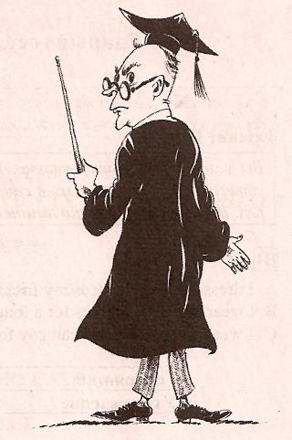
- If I owned a car, I would drive to work. But I don't own a car.
- A: What would you do if you won the lottery?
B: I would buy a house.
Form :
If +Past Simple, would + bare infinitive

EXCEPTION: If I were ... Глагол to be в условных предложениях второго типа (the Second Unreal Conditional) принимает форму were независимо от лица и числа.

Examples:
- If he were French, he would live in Paris.
- If she were rich, she would buy a yacht.
- I would play basketball if I were taller.
- I would buy that computer if it were cheaper.

Exercise 3:
a) Complete the Second Conditional Sentences.
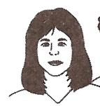
If I played the lottery, I would have a chance to hit the jackpot.

Janine is a daydreamer. She imagines what would happen if she won the lottery.
1. If I played the lottery, I (have) a chance to hit the jackpot.
2. If I hit the jackpot, I (be) rich.
3. If I were rich, my life (change) completely.
4. I would buy a lonely island, if I (find) a nice one.
5. If I owned a lonely island, I (build) a huge house by the beach.
6. I would invite all my friends if I (have) a house by the beach.
7. I would pick my friends up in my yacht if they (want) to spend their holidays on my island.
8. We would have great parties if my friends (come) to my island.
9. If we liked to go shopping in a big city, we (charter) a helicopter.
10. But if my friends' holidays were over, I (feel) very lonely on my lonely island.

