READ THE PARAGRAPHS AND DO THE EXERCISES

SUBJUNCTIVE II
Forms: Subjunctive II has two basic forms: non-perfect Subjunctive II is synthetical and is homonymous with the Past Indicative: spoke went, built, wrote, did, etc. The only exception is the verb to be whose. Subjunctive II form is were for all persons: I/she/he/it were. (Was is also possible with I/he/she/it and is more common in conversational English). Perfect Subjunctive II is homonymous with the Past Perfect Indicative for all verbs: had been, had done, had gone, had written, etc. Meaning: Subjunctive II represents an action as contrary to reality:
If only the conflict stopped. Ах, если бы конфликт прекратился!

Use: Subjunctive II is used in the following simple structures:
1. in exclamatory sentences beginning with 'Oh, that...', 'If only...':
Oh, that the storm were over! (present)
If only Rowley had come! (past)
If youth knew; if age could.
Such sentences express wish or regret and are characteristic of
literary style.
2. Subjunctive II is found in simple sentences with modal verbs.
In the sentences referring to the present or future the modal verb in Subjunctive II is followed by a non-perfect infinitive, in the sentences referring to the past — by a perfect one:
Could you come again tomorrow?
You might have opened the door for me.
3. Subjunctive II is also found in simple sentences containing the modal phraseological expressions had better, had best, would rather, would sooner. Such sentences express preference or advice:
I would rather know the painful truth than imagine it.
(preference)
You'd better keep out of sight until it's all over, (advice)

USE OF / WISH FOR REGRET AND DESIRE

As we saw, the idea of something contrary to present fact is conveyed by the use of Subjunctive II: I'd rather you told me what you think. We also use Subjunctive II to refer to present unreality after the verb wish (if only also expresses the wish of the speaker), and after expressions like It's time: I wish (that) I were rich! If only I were rich! It s time (It s about time, It s high time) we left.
We never use the present tense or a future form of the Indicative Mood after wish. We use either Subjunctive II as illustrated above, or the modal would (not will) to invite someone's co-operation or to indicate that people or events frustrate our desires: I wish you would hurry up! Compare: / hope it will stop raining soon.
Here is another example. It is raining. Jill wants to go out, but not in the rain. She says: I wish it would stop raining. (If only it would stop raining!) This means that Jill is complaining about the rain and wants it to stop.
We use I wish ... would ... when we wait something to happen or when we want somebody to do something. The speaker is not happy with the present situation. The phone has been ringing for five minutes -I wish somebody would answer it. I wish you would do something instead of just sitting and doing nothing.
You can use I wish ... wouldn't ... to complain about things people do repeatedly: I wish you wouldn 't interrupt me.
We use I wish ... would... for actions and changes, not situations.
Compare:
I wish Sarah would come. (= I want her to come.)
I wish Sarah were here now. (Not 'I wish Sarah would be ...')
I wish somebody would buy me a car.
I wish I had a car. (Not'I wish I would have ...')
Do the following exercise:
Exercise 1. Fill in the correct form of the verbs in brackets. *
- I wish I (meet) that actor when he was in town.
- He wishes he (buy) that book last week - now he
hasn't got enough money.
- If only I (be) older, I could have a driving licence.
- I wish I (can) remember where that book is.
- Tony wishes he (go) to Paris with his brother, but he
has to work.
(not eat) the tickets - now we can't go
- If only the dog
to the show.
- If only I (not make) that mistake yesterday.
- I wish this box (not be) so heavy - I can't lift it.
9. We wish we (not leave) the gate open. Now the dog has escaped.
10. Paula wishes she (have) more time for gardening, but she hasn't.

THE CONDITIONAL MOOD
Forms: The Conditional Mood is an analytical form built up by means of the auxiliary verb should (for the 1st person) or would (for the other persons) and the infinitive. The non-perfect Conditional Mood employs the indefinite or continuous infinitive: should do, would be going; the perfect Conditional Mood is formed with the help of the perfect or perfect continuous infinitive: should have done, would have been reading.
In Modern English for the first person should and would are both possible with no real difference in meaning:
/ should (would) never have thought you read anything but the
sporting news.
Meaning: The Conditional Mood, like Subjunctive II, represents an action as contradicting reality. The difference between the two moods is in their form and in their usage.
Use: The Conditional Mood is used to denote unreal actions in the following simple sentences:
1. with an adverbial modifier of condition expressed by a but for-
phrase:
He would not have come, but for me.
2. with implied condition:
/ wouldn't waste my time on rubbish in your place, (condition is implied in the phrase in your place = If I were in your place)
3. to sound" polite, less straightforward. Here the Conditional
Mood differs from the Indicative only stylistically, the perfect Conditional expressing the highest degree of politeness:

COMPLEX SENTENCES WITH SUBORDINATE CLAUSES OF UNREAL CONDITION

If-clauses of Unreal | If-clauses of Unreal | If-clauses of Unreal | Inversion
Condition Referring | Condition Referring | Condition of Mixed
to the Present or | to the Past | Type
Future
1. If she accepted | If I had not fallen ill | You wouldn't have | Had I known his
his invitation to | all of sudden, I woulwouwowould | allowed the child- | address, I would
visit him this | have left for the | ren to go boating | have called on
summer, they would | South long ago. (But I  fell ill and didn't | alone if you were | him when on ho-
have a nice time |  | more sensible. | liday in his town
together. (But | leave for the South.)
she probably
won't accept his
invitation.)
2. If I were on holi- |  | I shouldn't be so
day now, I should |  | busy now if I had
(would) go to a |  | got everything ar-
picturesque cor- |  | ranged for the trip
ner of the count- |  | beforehand.
ry. (But of course
I ami not on holi-
day now and can't

Exercise 2. Practise these sentences aloud and comment on the use of if-
clauses of unreal condition.
1. If I were given a chance to visit England, Г would be very happy as I am studying English at the Institute. 2. If I went to England, I would see all historic buildings and places as I am greatly interested in English history. 3. If it were summer, we would probably go to the seaside in the South of England. 4. If the hotel rates were not high, I should stay in a hotel. 5. If the hotel rates were too high, I should prefer to go to a holiday camp where I could make friends with as many people as possible. 6. If the weather were fine, I should probably have a walking holiday as it is much cheaper.
Exercise 3. Make up and act out a dialogue based on the picture using the
following sentence patterns.
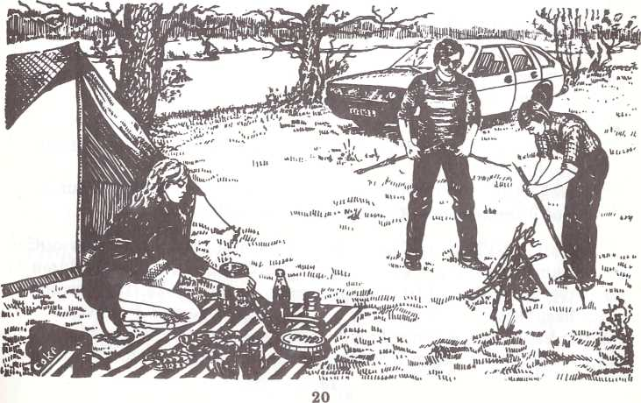
1. If they had arrived at the forest earlier, they would have gone mushrooming and of course they would have fried mushrooms for lunch. 2. If they had left the kettle at home, they wouldn't be able to boil tea now. 3. Had Harry taken a fishing rod, he could have caught some fish. 4. If Nora were a bad housewife, she wouldn't have taken so many tasty things with her.
I.
Exercise 4. Comment on the use of if-clauses of unreal condition.
1. Had the weather been lovely, we would have gone to the country for the weekend. 2. If we had gone to the country, we would have felt the awakening of nature. 3. If the orchards were in blossom now, the air would be very fragrant. 4. If the soil were not so wet, I would go and sit under those lovely young trees. 5. If the shower hadn't come on all of a sudden, I wouldn't have got wet through. 6. Had I taken an umbrella this morning, I would have escaped the worst of the rain. 7. If you accepted my invitation to visit me, I would take you round the town and show you the sights. 8. If you felt like studying in summer, you would attend a few lectures at a holiday course given at the college. 9. If you were going to stay in the South only a few days, you woudn't take so much luggage with you. 10. If she were more sociable, she wouldn't have got away from other people when on holiday in a holiday camp.
Exercise 5. Change into sentences of unreal condition.
1. Ann is going to stay in London only a few days. She will take very little luggage with her. 2. She is sure that it will be raining when she gets to London, so she'll take her lovely new umbrella with her. 3. She will sleep soundly in a sleeping car as she will travel all night and arrive in London only in the morning. 4. Her friend is a talkative social person. They will have a long chat talking about all sorts of things. 5. The weather didn't keep fine. We didn't stay in the country for another ten days. 6. We didn't pack out things long before going to the station. We had to hurry not to miss the train. 7. Mario is not rich enough. He didn't afford to stay at a hotel at the seaside last year. 8. Margaret is so forgetful. She left her railway ticket at home, had to return for it and missed the train. 9. Peter lived quite a distance from the station. He had to take a taxi to get to the station in good time.
Exercise 6. Translate into English.
1. Если бы нам удалось разжечь костер, мы бы вскипятили воду и напились горячего чаю. Но мы оставили спички на турбазе. 2. Только что прошел дождь. Если бы земля была сухая⁴, мы бы отдохнули прямо на песке на берегу реки. 3. Если бы мне предоставилась возможность провести пару недель где-нибудь в горах или на берегу моря, я была бы очень счастлива. 4. В прошлом году мы были на берегу Черного моря. Если бы ты поехала с нами, ты бы чудесно провела время. 5. Когда мы подошли к станции, электричка уже ушла. Поспеши мы немного, мы бы успели на нее. 6. Если бы мы подождали следующий автобус, мы были бы на турбазе через два часа. 7. Если бы ты интересовалась достопримечательностями, я бы показала тебе много мест, связанных с историей города. 8. Если бы она была более гостеприимна, она бы предложила нам остаться еще на несколько дней. 9. Если бы вы хоть раз провели отпуск в турпоходе, вы бы были другого мнения о таком отдыхе. 10. Он бы с большим удовольствием совершил поездку по Волге, если бы получил отпуск летом.

