Third Conditional (Unreal)

Условные предложения третьего типа (нереальные)(Third Conditional (Unreal) выражают невероятные предположения, действия которых относится к прошедшему времени.
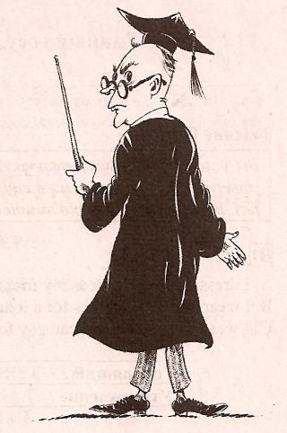
Form :
if + past perfect, would have+past participle

Examples:
- If I had known you were coming, I would have met you at the station last Sunday.
- If you had reminded me, I would not have forgotten to do it.


Exercise 1: Complete the Third Conditional Sentences by putting the verbs into the correct form.
If you had asked me, I would have helped you yesterday.
1. If you had studied for the test, you (pass) it.
2. If you (ask) me, I would have helped you yesterday.
3. If we had gone to the cinema last Sunday, we (see) my friend Jacob.
4. If you (speak) English, she would have understood you.
5. If you (phone) me yesterday, I would have told you the news.
Exercise 2: Say what you would have done if the weather had been fine yesterday.



Student A: Student B:
What would you have done, if the weather had been fine last weekend?

If the weather had been fine last weekend, I would have gone for a picnic with my friends.

Prompts: to go to the zoo, to go fishing, to go boating, to take my son to the seaside, to play football, to invite my friend for a walk, to go sightseeing, to plant rose-bushes in my garden, to go to the park, not to stay at home.

