I. READ THE DEINITIONS. MATCH THE DEFINITIONS WITH THE APPROPRIATE NOTIONS:
1. It can be defined as all the ways of life including arts, beliefs, and institutions of a population that are passed down from generation to generation. Culture has been called "the way of life for an entire society." As such, it includes codes of manners, dress, language, religion, rituals, games, norms of behavior such as law and morality, and systems of belief as well as the art.
2. Mental acceptance of and conviction in the truth, actuality, or validity of somethin. Something believed or accepted as true, especially a particular tenet or a body of tenets accepted by a group of persons.
3. A system of accepted beliefs which control behavior, especially such a system based on morals.
4. Beliefs of a person or social group in which they have an emotional investment (either for or against something).
"He has very conservatives values"
5. The social process whereby societies achieve an advanced stage of development and organization
6. A fixed idea that people have about what someone or something is like, especially an idea that is wrong.
7. The fact or quality of cultures of being diverse or different.
8. Culture/customs which make a country distinctive/different from other countries.
9. Mistaken thoughts, idea, or notion; misunderstandings about a culture. These are false ideas about a culture resulting from misunderstanding rather than from reality.
10. a condition of confusion and anxiety affecting a person suddenly exposed to an alien culture.
11. Behavior resulting from a belief that race accounts for differences in human character or ability and that a particular race is superior to others (racism or racialism.)
12. The entire world and its inhabitants. The world thought of as being closely connected by modern communication and trade and thus eliminating borders.
13. The process of transformation of local phenomena into global ones. It can be described as a process by which the people of the world are unified into a single society and function together. This process is a combination of economic, technological, sociocultural and political forces.
14. A generalized perception of first impressions. It can instigate prejudice and false assumptions about entire groups of people, including the members of different ethnic groups, social classes, religious orders, the opposite sex, etc.
a) racial behaviour,
b) value,
c) global village,
d) civilization,
e) cultural stereotypes,
f) cultural uniqueness,
g) cultural misconceptions,
h) cultural shock,
i) culture,
j) globalization,
k) belief,
l) cultural diversity
II. SCAN THE TEXT AND FULFILL THE TASKS BELOW::
What is culture?
Culture is a powerful human tool for survival, but it is a fragile phenomenon. It is constantly changing and easily lost because it exists only in our minds. Our written languages, governments, buildings, and other man-made things are merely the products of culture. They are not culture in themselves.
In order to live man, like all other species, must come to terms with the external world.... Man employs his sense organs, nerves, glands, and muscles in adjusting himself to the external world. But in addition to this he has another means of adjustment and control.... This mechanism is culture.
Layers of Culture.
There are three layers or levels of culture that are part of your learned behavior patterns and perceptions. Most obviously is the body of cultural traditions that distinguish your specific society. When people speak of Italian, or Japanese culture, they are referring to the shared language, traditions, and beliefs. In most cases, those who share your culture do so because they acquired it as they were raised by parents and other family members who have it.
The second layer of culture that may be part of your identity is a subculture. In complex, diverse societies in which people have come from many different parts of the world, they often retain much of their original cultural traditions. As a result, they are part of an identifiable subculture in their new society. The shared cultural traits of subcultures set them apart from the rest of their society. Examples of easily identifiable subcultures in the United States include ethnic groups such as Vietnamese Americans, African Americans, and Mexican Americans. Members of each of these subcultures share a common identity, food tradition, dialect or language, and other cultural traits that come from their common background and experience.
The third layer of culture consists of cultural universals. These are learned behavior patterns that are shared by all of humanity collectively. No matter where people live in the world, they share these universal traits. Examples of such "human cultural" traits include:
1. | communicating with a verbal language consisting of a limited set of sounds and grammatical rules for constructing sentences
2. | using age and gender to classify people (e.g., teenager, senior citizen, woman, man)
3. | classifying people based on marriage and relationships and having kinship terms to refer to them (e.g., wife, mother, uncle, cousin)
4. | raising children in some sort of family setting
5. | having a sexual division of labor (e.g., men's work versus women's work)
6. | having a concept of privacy
7. | having rules to regulate sexual behavior
8. | distinguishing between good and bad behavior
9. | having some sort of body ornamentation
10. | making jokes and playing games
11. | having art
12. | having some sort of leadership roles for the implementation of community decisions

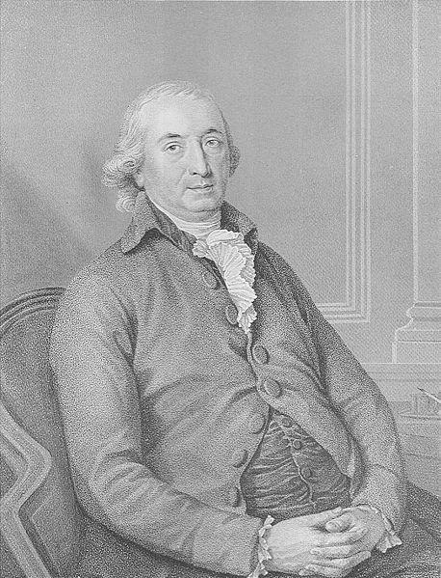  Johann Herder  called attention to national cultures | 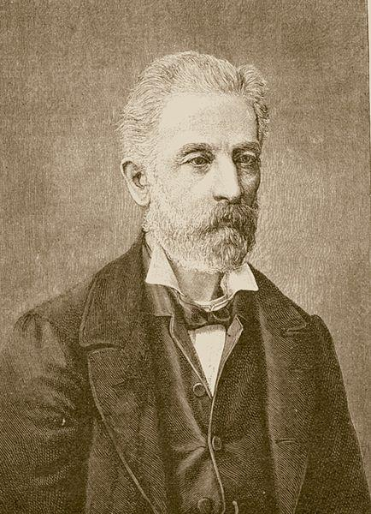  Adolf Bastian  developed a universal model of culture
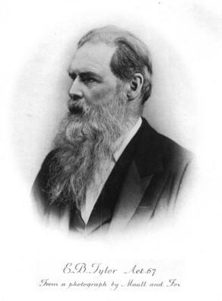  Edward Tylor  British anthropologist was one of the first English-speaking scholars to use the term culture in an inclusive and universal sense | 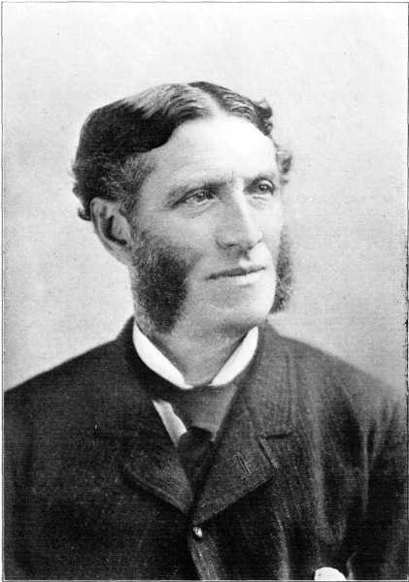  Matthew Arnold  British poet and critic viewed "culture" as the cultivation of the humanist ide

Task 1. Comprehension questions:
1. What meanings of the word “culture” do you know?
2. What is your definition of the notion “culture” ?
3. What do biologists imply by the notion “culture?
4. By whom was the term “culture” first used?
6. Why is it a fragile phenomenon?
7. What layers of culture are presented in the text?
8. What "human cultural" traits do you know?
Task 2. Match up two halves of the sentences.
A | B
1. Culture is | a) they are referring to the shared language, traditions, and beliefs.
2. When people speak of Italian, or Japanese culture, | b) different meanings.
3. The second layer of culture consists of | c) cultural universals.
4. The third layer of culture consists of | d) to national cultures.
5. Johann Herder called attention | e) a powerful human tool for survival.
6. The word culture has many | f) subcultural.

III. READ THE CHARACTERISTICS OF CULTURE.
CHOOSE THREE WHICH ARE THE MOST IMPORTANT IN YOUR OPINION. EXPLAIN YOUR CHOICE:

Characteristics of Culture
- Culture is prescriptive. It prescribes the kinds of behavior consideredÂ acceptable in the society. The prescriptive characteristics of culture simplify a consumer’s decision-making process by limiting product choices to those, which are socially acceptable.
- Culture is socially shared. Culture, out of necessity, must be based on social interaction and creation. It cannot exist by itself. It must be shared by members of a society, thus acting to reinforce culture’s prescriptive nature.
- Culture facilitates communication. One useful function provided by culture is to facilitate communication. Culture usually imposes common habits of thought and feeling among people. Thus, within a given group culture makes it easier for people to communicate with one another. But culture may also impede communication across groups because of a lack of shared common cultural values.
- Culture is learned. Culture is not inherited genetically-it must be learned and acquired. Socialization or enculturation occurs when a person absorbs or learns the culture in which he or she is raised. In contrast, if a person learns the culture of a society other than the one in which he or she was raised, the process of acculturation occurs. The ability to learn culture makes it possible to absorb new cultural trends.
- Culture is subjective. People in different cultures often have different ideas about the same object. What is acceptable in one culture may not necessarily be so in another. In this regard, culture is both unique and arbitrary.
- Culture is enduring. Because culture is shared and passed along from generation to generation, it is relatively stable and somewhat permanent. Old habits are hard to break, and people tend to maintain its own heritage in spite of a continuously changing world. This explains why India and China, despite severe overcrowding, have a great difficulty with birth control. The Chinese view a large family as a blessing and assume that children will take care of parents when growth old.
- Culture is cumulative. Culture is based on hundreds or even thousands of years of accumulated circumstances. Each generation adds something of its own to the culture before passing the heritage on to the next generation.
- Culture is dynamic. Culture is passed along from generation to generation, but one should not assume that culture is static and immune to change. Far from being the case, culture is constantly changing-it adapts itself to new situations and new sources of knowledge.

IV.READ THE TEXT "CULTURE". TRANSLATE THE PASSAGES BELOW USING THE TEXT.
ARRANGE THE TRANSLATED PASSAGES IN A LOGICAL ORDER:
Culture
In the modern world people are judged not only by what they do but how they do it. Life in the society is impossible without everyday contacts and meetings, so all relationships depend on the way people behave and treat each other. Human relations and communication skills are important.
That’s why along with education, people should develop cultural issues. The word “culture” has many meanings. One of the most common explanations refers to the spiritual and material achievements of the humanity.
There are many types of culture. For example, folk culture, popular culture, corporate culture, elite culture, etc. They are all closely connected. Folk or national culture is like a habit of people. It is the everyday life and routine of certain group of people. Elite culture is well-developed and many-sided. It is the attitude towards art, architecture, theatre, music, literature. Popular or mass culture gives people standards to be what they like. It is especially suitable for young people. Corporate culture is collective beliefs and value systems of a certain company.
Thus, all types of culture require certain model of behavior or set of rules for social conduct. However, one thing is common for all people. It’s politeness – the most important sign of any culture. It’s not only saying “Excuse me”, “Sorry”, “Good morning”, “Bless you”. Politeness is something that should be developed in every sphere of life. For example, greeting people you know in the street, wishing your friend a nice day, offering a seat to old people – these are all signs of politeness.
So, living a civilized life in accordance with culture isn’t as difficult as it might seem.

PASSAGES FOR TRANSLATING:
1. Таким образом, все типы культуры требуют определенной модели поведения или ряда правил социального поведения. Тем не менее, одно является общим для всех людей. Это вежливость – самый важный признак любой культуры. Это не только слова «простите», «извините», «доброе утро», «будьте здоровы». Вежливость это то, что должно проявляться во всех сферах жизни. Например, приветствовать знакомых на улице, желать другу хорошего дня, уступать место старшим – все это признаки вежливости.

2. Вот почему наряду с образованием, люди должны развивать в себе и навыки культуры. Слово «культура» имеет много значений. Одно из самых распространенных объяснений относит его к духовным и материальным достижениям человечества.

3. Как видно, жить цивилизованной жизнью в соответствии с культурой не так сложно, как кажется.
4. В современном мире людей судят не только по тому, что они делают, но как они это делают. Жизнь в обществе невозможна без повседневных контактов и встреч, так что отношения зависят от того, как люди ведут себя и относятся друг к другу. Человеческие отношения и коммуникативные навыки важны.

5. Различают много типов культуры. Например, народная культура, массовая культура, корпоративная культура, элитарная культура и т.д. Они все тесно взаимосвязаны. Народная или национальная культура как привычка людей. Это повседневная жизнь и рутина определенной группы людей. Элитный тип культуры хорошо развит и многогранен. Это отношение к искусству, архитектуре, театру, музыке, литературе. Популярная или массовая культура задает людям стандарты того, что им нравится. В особенности это относится к молодежи. Корпоративная культура – это коллективные убеждения и система ценностей определенной компании.

