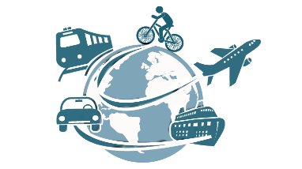
Task (Travelling)
- Watch the video «Means of Transport»
https://www.youtube.com/watch?v=dpgM3Vo2y-M

- Fill in the table «Pros and Cons of Different Means of Transport»:
Means of transport |   Pros |   Cons

